Mohamed AbdulAmeer Mirza Ahmed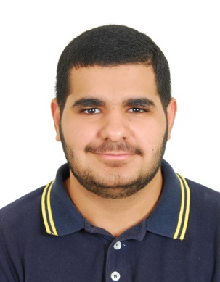

|  |
| --- |
| Personal Details |

* **Date of Birth:** November 19,1998
* **Nationality:** Bahraini
* **Contacts: Mob.** +973 38090069 – 33056298  **Email:** [Mohad11ameer@gmail.com](mailto:Mohad11ameer@gmail.com)
* **Marital status:** Single

|  |
| --- |
| Academic Qualifications |

Jadhafs Secondary Industrial School for Boys (2017 – 2014 )

Training in Alba Aluminum Company from 25/09/2016 to 03/11/2016

|  |
| --- |
| Personal Characteristics |

* Personal Character:
* Fast learning
* Simple
* Effective communication
* Professional Abilities:
* Effective use of information technology
* Computing Skills:

Program

Microsoft office suite – Internet – most social media platforms

* Languages:

Arabic & English

* Interests & Hobbies:

Playing football & Reading newspaper